
C/C++ COUNTING CHANGE PROGRAM LAB REPORT
1) Enter your name, student ID, platform (Mac or PC) and date
Name and Student ID: Jay Gupta, Student ID: 0961979
Platform (Mac, PC, Linux, etc.): PC
Development System (Visual Studio, Xcode, etc.): Visual Studio
Date: 2/9/2020
OBJECTIVES:
Enter and successfully run a C or C++ program
Use console input to read data from the keyboard
Calculate a total value for quarters, dimes, nickels and pennies
Use console output to display total
DESCRIPTION:
Write a program that counts change. The program should ask for the number of quarters, the number of dimes, the number of nickels and the number of pennies. The program should then compute the value of all the coins and tell the user how much money there is, expressed in dollars with two digits past the decimal point.
Display a title at the top of the screen when the program first runs. You must use constants for the value of each coin type. Multiply the number of each coin times the value for each coin using a constant for the value of each coin type. Refer to the PowerPoint or video on using the Paycheck program as a reference when writing the Counting Change project..
INPUTS | PROCESSING | OUTPUTS
quarters  dimes  nickels  pennies | Display Title message  Read quarters from keyboard  Read dimes from keyboard  Read nickels from keyboard  Read pennies from keyboard  Compute the total of all the coins  Display total | total
SAMPLE OUTPUT:
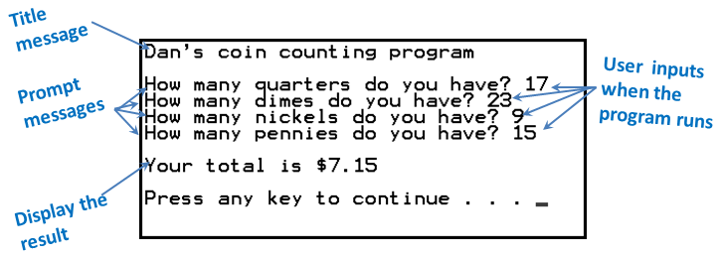
In this example, if you tell the program when it runs that you have 17 quarters, 23 dimes, 9 nickels and 15 pennies, the program then computes the total value of all your coins. The program then tells you that the value of all your coins is $7.15.
LAB REPORT:
2) Fill in the TEST VALUES & RESULTS table
Fill in the Test Data Values and Expected Results as shown on the lab assignment.
*** You need to choose your test values and replace the ?? with your chosen test values ***
Fill in the Actual Results after you have run and tested your program
TEST DATA VALUES  Choose your test values. Replace each ?? with your choice | EXPECTED RESULT  Computed values before  the program is run | ACTUAL RESULT  Fill in the output displayed  by the program
quarters = 100  dimes = 100  nickels = 100  pennies = 50 | Your total is: $40.50 | Your total is: $40.50
quarters = 46  dimes = 90  nickels = 0  pennies = 13 | Your total is: $20.63 | Your total is: $20.63
quarters = 24  dimes = 12  nickels = nine  pennies = 245 | Error; Code will break | Enter the number of quarters: 24  Enter the number of dimes: 12  Enter the number of nickels: nine  Enter the number of pennies: (didn’t allow me to enter in # of pennies)  Your total is: $7.20
DISCUSSION:
3) Complete the DISCUSSION section. It does not need to be long, but it needs to be complete.
3a) What did you do to develop the program? ("Followed the Directions" is not a complete description
I first decided on what the output will look like, and then, based on the inputs and outputs, I decided on the constant values (value of each coin). Then, I typed all the “cout” statements, defining the variables along the way. I then tested the program multiple times, to make sure it was accurate.
3b) What problems did you have and how did you overcome the problems?
I made a logic error, at one point; I put a “+” instead of a “*” near pennies and PENNY_VALUE. This messed up my output, because I was getting a much higher value than expected output. I read through the “total” definition and eventually fixed the error.
In addition, I had to review setting two decimal places. I went to the paycheck program, and didn’t understand the syntax very much, and as a result, I went to the internet and queried the 2 decimal issue. I finally understood, that “fixed” meant after the decimal, and set precision actually set the 2 decimal places.
PROGRAM OUTPUT:
4) Show three screenshots showing each of the test conditions listed in section 2) of the lab report
IMPORTANT: Capture only the portion of the screen that shows the program output. Do not capture the entire screen even though it may also contain the program output. Many times when I zoom in on the output window, the image resolution is so poor that I am not able to read your output. If this happens, I will ask that you resubmit your lab report.
For the Mac, hold down command + shift keys and press the 4 key to get a screenshot of a selected area of the screen. Use the mouse or touchpad to select the desired area.
Use command+V to paste the clipboard into the lab report.
For Windows, There are two ways you can capture a screen shot of only your program:
Use Microsoft's Snipping Tool by clicking on the Start icon and selecting "All Programs" then "Accessories". Use the mouse to select the area of the screen you want to save then click Ctrl-C or select the menu items Edit-Copy to save the image to the clipboard.
Capture the active window to the clipboard by holding down the Alt key and tapping the PrintScreen key. NOTE: some notebook computers require that you hold down a [Fn] key and Alt keys to activate the PrintScreen function. NOTE: Do not click PrintScreen without the Alt key. This would capture the entire screen which would make your program output difficult to see.
Use Ctrl+V to paste the clipboard into the lab report.
Place your screenshots here
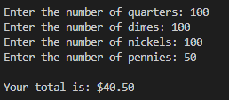

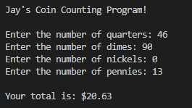

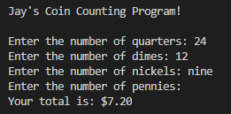
PROGRAM LISTING:
5) Copy and paste the code that YOU typed to make the program work. Your program must include a comment block at the top that shows the name of the program, date, version and your name.

/* C++ CountingChange.cpp
Version: V1.0
Jay Gupta
CIS054 C/C++ Programming
Date: 2/9/2020

Project Description:
- Counts change and tells the user how many money,
in dollars, he/she has.
Inputs: count of: quarters, dimes, nickels, pennies
Outputs: how much money (in dollars) there is
*/

#include <iostream> // cin and cout
#include <iomanip> // 2 digits past the decimal
using namespace std;

// define the constants
const double QUARTER_VALUE = 0.25;
const double DIME_VALUE = 0.10;
const double NICKEL_VALUE = 0.05;
const double PENNY_VALUE = 0.01;

int main()
{
// declare the variables

// coin types
int quarters;
int dimes;
int nickels;
int pennies;

// total
double total;

// title
cout << endl << "Jay's Coin Counting Program!" << endl << endl;

// input: # of each type of coin
cout << "Enter the number of quarters: ";
cin >> quarters;
cout << "Enter the number of dimes: ";
cin >> dimes;
cout << "Enter the number of nickels: ";
cin >> nickels;
cout << "Enter the number of pennies: ";
cin >> pennies;

total = quarters * QUARTER_VALUE + dimes * DIME_VALUE
+ nickels * NICKEL_VALUE + pennies * PENNY_VALUE;

cout << fixed;
cout << setprecision(2);
cout << endl << "Your total is: $" << total << endl << endl;
}

